Chinese-European Dispute Resolution Seminar
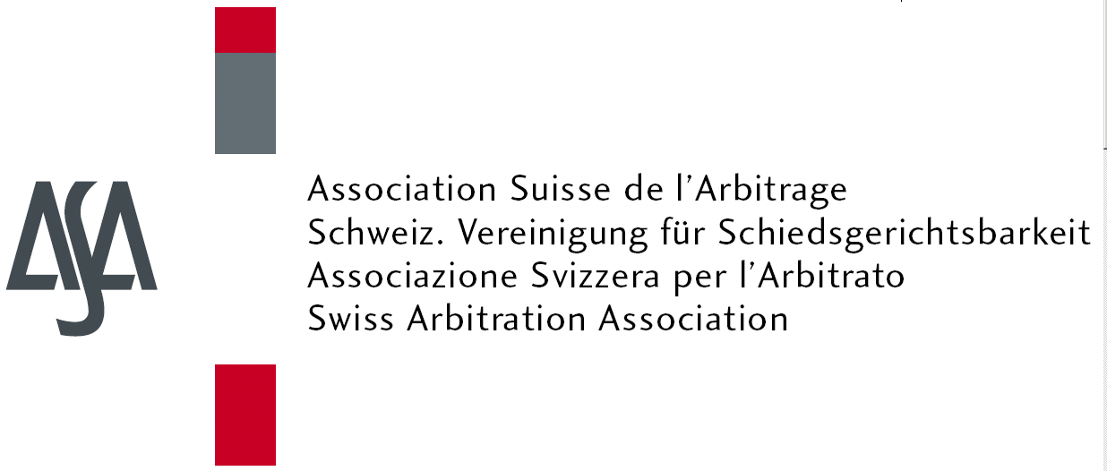

18 June 2016

Enterprise Dream Park
Qianhai Shenzhen-Hong Kong Modern Service Industry Cooperation Zoon, Shenzhen, China

Programme
18 June 2016
08.30-09.00 | Registration
09.00-09.20 | Welcome andIntroduction | Mr. Beat Schmid, Deputy Consul General, Consulate General of Switzerland in Guangzhou  Mr. Elliott Geisinger, President of ASA, Schellenberg Wittmer Ltd, Partner, Geneva  Mr. Vivian Desmonts, SCIA Arbitrator, DS Avocats, Partner  Dr. Liu Xiaochun, President of SCIA
09.20-10.45 | - Latest Development of Arbitration between China and Europe  - Switzerland, an Arbitration Hub atthe Heart of Europe  - Risk Prevention in European Investment between Chinese and European Enterprises | Prof. Peter Malanczuk, SCIA Council Member  Ms. Mariana Zhong, Dechert LLP, Senior Associate, Beijing  Mr. Felix Dasser, Homburger, Partner, Zurich  Mr. Urs Zenhäusern, Baker & McKenzie, Partner, Zurich  Mr. Huen Wong, BBS JP, SCIA Council Member, President of the Inter-Pacific Bar Association, Hong Kong
10.50-11.15 | Coffee Break
11.15-12.30 | - Dispute Resolution Institution in China and Europe: Cultural Similarities and Differences  - Arbitration Swiss Style: Location, Law and Arbitration Rules  - Efficiency in Arbitral Proceedings, Including Interim Measures | Mr. Jingzhou Tao, SCIA Arbitrator, Dechert LLP, Partner, Beijing  Mr. Bernhard Meyer, Vice President of ASA  Mr. Marc Veit, LALIVE, Partner, Zurich  Mr. Craig I. Celniker, SCIA Arbitrator, Morrison & Foerster, Partner, Hong Kong
12.30-14.00 | Luncheon

Lecturers:

- Mr. Alexander McLin, Executive Director of ASA, Geneva
- Mr. Bernhard Meyer, Vice President of ASA
- Mr. Craig I. Celniker, SCIA Arbitrator, Morrison & Foerster, Partner, Hong Kong
- Mr. Elliott Geisinger, President of ASA, Schellenberg Wittmer Ltd,
Partner, Geneva
- Felix Dasser,Homburger, Partner, Zurich
- Mr. Huen Wong, BBS JP, SCIA Council Member, President of the Inter-Pacific Bar Association, Hong Kong
- Marc Veit, LALIVE, Zurich
- Mr. Beat Schmid, Deputy Consul General, Consulate General of Switzerland in Guangzhou
- Prof. Peter Malanczuk, SCIA Council Member Jingzhou Tao, Dechert LLP Beijing
- Mariana Zhong, Dechert LLP Beijing
- Mr. Urs Zenhäusern, Baker & McKenzie, Partner, Zurich
- Mr. Vivian Desmonts, SCIA Arbitrator, DS Avocats, Partner
- Dr. Liu Xiaochun, President of SCIA
- Mr. Jingzhou Tao, SCIA Arbitrator, Dechert LLP, Partner, Beijing
- Dr. Liu Xiaochun, President of SCIA.
- Ms. Mariana Zhong, Dechert LLP, Senior Associate,Beijing

Who should attend:
Lawyers, in-house counsel and members of companies engaged in international business and dispute resolution.

Mock case:
Participants will have the opportunity to work with a mock case
Costs:
This seminar is free of charge. Pre-registration is required.

Registration:
Please register to event@lexpr.net

Event Venue:
Enterprise Dream Park，Qianhai Shenzhen-Hong Kong Modern Service Industry Cooperation Zoon, Shenzhen, China

AboutOrganizers
Co-organizers
ASA -  Swiss  Arbitration Association | The Swiss Arbitration Association(ASA) has over 1200 members, practitioners and academics engaged and/or interested in domestic and international arbitration, from Switzerland and abroad. ASA contributes to the development of arbitration law and practice through regular conferences and workshops, including this Annual Conference; the Arbitration Workshop Seminar; ASA Local Group meetings; ASA below 40 events for young practitioners, and the publication of the ASA Bulletin, a renowned arbitration quarterly, and of the ASA Special Series.  For more information, please see:www.arbitration-ch.org
SCIA-  Shenzhen  Court of International Arbitration | South China International Economic and Trade Arbitration Commission (also known as the Shenzhen Court of International Arbitration; previously known as the China International Economic and Trade Arbitration Commission South China Subcommission, the China International Economic and Trade Arbitration Commission Shenzhen Subcommission; hereinafter the “SCIA”) was established in 1983 in Shenzhen Special Economic Zone. It is an arbitration institution founded to resolve the contract disputes and other property rights disputes amongst individuals, legal entities and other institutions from domestic China and overseas.
Supporter

LexPR-  Beijing LexPR Consulting | The Beijing LexPR Consulting Co., Ltd.is a professional legal public relation company in Beijing with a deep understanding of the China’s legal field market, the culture, and the communication method between China and other nations.  For more information, please see: www.lexpr.net

